CLASH JUMPER POLICY

Effective Date – 1st July 2016

Review Date – 1st March 2017

- Introduction
The purpose of this policy is to provide guidelines around when teams are required to wear the Narre North Foxes clash jumper.

- Background
Narre North Foxes currently have two registered jumpers that can be worn during matches played within the South East Junior Football League (SEJFL).

Black Jumper White Jumper
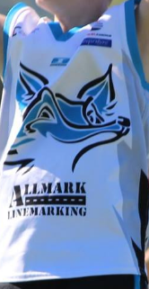
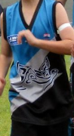

Traditionally the black jumper has been treated as a “home” jumper and worn for all home games and the white jumper has been used as the “away” jumper and worn for all away games.

Not all incorporated SEJFL have both two jumpers available for use. In fact the majority only have their registered “home” jumper every week.

The black jumper is the recognised main jumper and the preference is to play in those colours whenever possible.

- Scope
This policy applies to all Narre North Foxes football teams that have both a black jumper and a white jumper available for use.
This policy applies for all minor round matches and finals matches regardless of venue.

- Policy
All teams will use the black jumper for all games with the exception of games against the following clubs (whose traditional colours are deemed to clash with the black jumper).

- Berwick (see condition below)
- Cora Lynn
- Hampton Park

All matches against the above clubs (regardless of venue) are to be played in the white “clash” jumper.

Condition (Berwick) – If a home match and the Berwick team are wearing their clash jumper, then black jumper to be worn. Team Manager to manage on the day of game.

AUTHORISED BY

.
President

.
Vice President

- APPENDIX A
SEJFL MEMBER CLUB JUMPER EXAMPLES

NARRE NORTH FOXES - BLACK | NARRE NORTH FOXES - WHITE

BEACONSFIELD | BERWICK | BERWICK SPRINGS

CORA LYNN | CRANBOURNE | DOVETON EAGLES
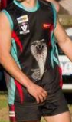

ENDEAVOUR HILLS | ENDEAVOUR NORTH | FOUNTAIN GATE
 | 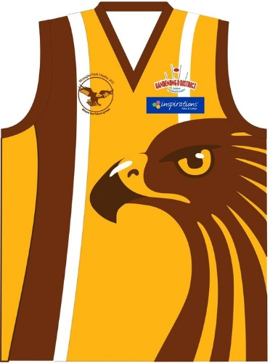 | 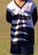

HALLAM | HAMPTON PARK | KOO WEE RUP
 | 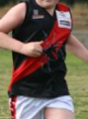 | 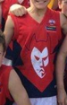

LYNDHURST | NARRE WARREN STH | NAR NAR GOON
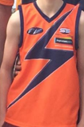 | 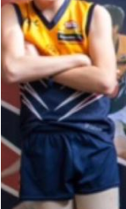 | 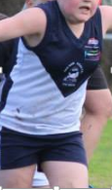

NARRE WARREN | NOBLE PARK | NORTH DANDENONG
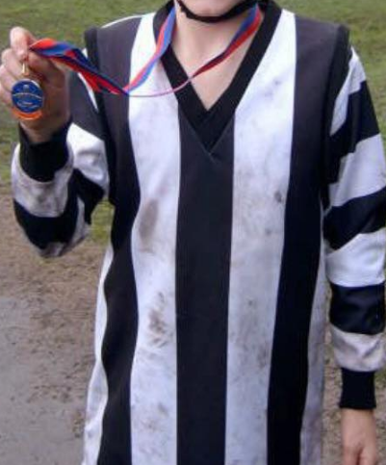 | 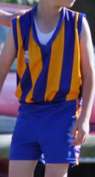

OFFICER | PAKENHAM | PARKMORE
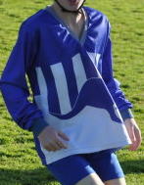 | 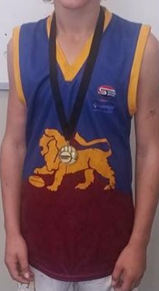

TIMBARRA | TOORADIN
